**A PROJECT ON**



**ATTENDENCE MONITORING USING FACE RECOGNITION**



**Submitted in partial fulfillment of the requirement for the award of the degree of**

**BACHELOR OF COMPUTER APPLICATION**

**Submitted by:**

**Prakhar Kukreja** **2102267**

***Under the Guidance of***

**Ms. Vandana Rawat**

**Assistant Professor**



**Department of Computer Application**

**Graphic Era (Deemed to be University)**

**Dehradun, Uttarakhand**

**DECEMBER-2023**



**CANDIDATE’S DECLARATION**

I/We hereby certify that the work which is being presented in the Project Report entitled **“Attendance Monitoring Using Face Recognition”** in partial fulfillment of the requirements for the award of the Degree of Bachelor of Technology in Computer Application and submitted in the Department of Computer Application of the Graphic Era (Deemed to be University), Dehradun is an authentic record of my own work carried out during a period from **November-2023 to December-2023** under the supervision of **Ms. Vandana Rawat, Assistant Professor**, Department of Computer Application, Graphic Era (Deemed to be University).

The matter presented in this dissertation has not been submitted by me/us for the award of any other degree of this or any other Institute/University.

Prakhar Kukreja 2102267 **Signature**

This is to certify that the above statement made by the candidate is correct to the best of our knowledge.

**Signature** **Signature**

**Supervisor** **Head of the Department**

**External Viva**

**Name of the Examiners: Signature with Date**

1.

2.

**Abstract**

Attendance Monitoring Using Face Recognition is an advanced system that utilizes computer vision and facial recognition technology to automate the process of attendance tracking. This contactless and efficient method offers significant advantages over traditional attendance monitoring systems. By enrolling participants and creating a database of facial templates, the system can accurately identify and authenticate individuals in real-time based on their facial features. This technology provides a hygienic alternative, particularly in the context of the ongoing COVID-19 pandemic, while reducing administrative efforts and eliminating manual errors. Attendance Monitoring Using Face Recognition enhances security by preventing fraudulent practices and ensures the integrity of attendance records. In educational institutions and workplaces, this system facilitates better attendance management, enables the identification of absenteeism patterns, and supports proactive measures for improving engagement and performance. However, privacy concerns and ethical considerations must be addressed to ensure compliance with data protection regulations and individual consent. Overall, Attendance Monitoring Using Face Recognition offers a modern and effective solution to streamline attendance tracking processes across different sectors, leading to improved efficiency and accountability.

**Keywords:** Attendance, Face Recognition.

**Acknowledgement**

Any achievement, be in scholastic or otherwise does not depend solely on the individual effort but on the guidance, encouragement and co-operation of intellectuals, elders and friends. A number of personalities in their own capacity have helped me in carrying out this project work.

Our sincere thanks to project guide **Ms. Vandana Rawat, Assistant Professor,** Department of Computer Application, Graphic Era (Deemed to be University), for his valuable guidance and support throughout the course of project work and for being a constant source of inspiration.

\We are extremely grateful to **Ms. Vandana Rawat**, Assistant Professor of the Computer Application Department, Graphic Era (Deemed to be University), for his moral support and encouragement.

We thank the **management of Graphic Era (Deemed to be University)** for the support throughout the course of our Bachelor’s Degree and for all the facilities they have provided.

Last, but certainly not least we thank all teaching and non-teaching staff of Graphic Era (Deemed to be University) for guiding us in the right path. Most importantly we wish to thank our parents for their support and encouragement.

Prakhar Kukreja 2102267

**Table of Contents**

|  |  |  |  |  |  |  |  |  |  |  |  |  |  |  |  |  |  |  |  |  |  |  |  |  |  |  |  |  |  |  |  |  |  |  |  |  |  |  |  |  |  |  |  |  |  |  |
| --- | --- | --- | --- | --- | --- | --- | --- | --- | --- | --- | --- | --- | --- | --- | --- | --- | --- | --- | --- | --- | --- | --- | --- | --- | --- | --- | --- | --- | --- | --- | --- | --- | --- | --- | --- | --- | --- | --- | --- | --- | --- | --- | --- | --- | --- | --- |
|  | |  |  | | --- | --- | | **Contents** | **Page No.** | | Abstract | i | | Acknowledgement | ii | | Table of Contents | iii | | **Chapter 1 Introduction** | **1-5** | | 1.1 Project Introduction | 1-2 | | 1.2 Problem Statement | 2-3 | | 1.3 Objectives | 3-5 | | **Chapter 2**  **Literature Survey/ Background** | **6-7** | | **Chapter 3 Software Design** | **8-9** | | **Chapter 4**  **Requirements and Methodology** | **10-14** | | 4.1 Requirements |  | | 4.1.1 Hardware Requirements |  | | 4.1.2 Software Requirements |  | | 4.2 Methodology |  | | **Chapter 5**  **Coding /Code Templates** | **15-16** | | **Chapter 6**  **Testing** | **17-19** | | **Chapter 7** **Results and Discussion** | **20-21** | | **Chapter 8 Conclusion and Future Work** | **22** | | **References** | **23** | |  |  | |  |  | |  |
|  |  |  |

**Lists of Tables**

|  |  |  |
| --- | --- | --- |
| **Table No.** | **TITLE** | **PAGE No.** |
| 1.1 | Main.py | 15 |

**Chapter 1**

**Introduction**

In the following sections, a brief introduction and the problem statement for the work has been included.

* 1. **Project Introduction**

Attendance monitoring is a critical aspect of various organizations, including educational institutions, workplaces, and events. Traditionally, attendance tracking has relied on manual methods such as paper-based sign-in sheets or ID card scanning, which can be time-consuming, prone to errors, and subject to fraudulent practices such as proxy attendance. However, with advancements in computer vision and facial recognition technology, a more efficient and reliable solution has emerged: Attendance Monitoring Using Face Recognition.

Attendance Monitoring Using Face Recognition leverages computer vision algorithms and machine learning techniques to automatically identify and verify individuals based on their facial features. This technology has gained significant attention and adoption due to its ability to provide accurate, real-time, and contactless attendance management.

The process begins with enrolling participants in the system by capturing their facial images and creating a database of unique facial templates. During attendance monitoring, the system captures real-time images or video streams and compares them with the enrolled templates to identify and authenticate individuals. By analyzing facial landmarks, features, and patterns, the system can accurately recognize individuals and record their attendance.

The benefits of Attendance Monitoring Using Face Recognition are numerous. First and foremost, it offers a contactless and hygienic alternative to traditional attendance tracking methods, especially in the context of the ongoing COVID-19 pandemic. It eliminates the need for physical contact with attendance devices, reducing the risk of transmission of contagious diseases.

Secondly, face recognition-based attendance monitoring significantly reduces administrative efforts and eliminates manual errors. The automated system can process attendance data in real-time, generating accurate reports and reducing the time spent on manual attendance management tasks. This allows organizations to streamline their administrative processes and allocate resources more effectively.

Furthermore, Attendance Monitoring Using Face Recognition enhances the overall security and integrity of attendance records. The technology is designed to prevent fraudulent practices such as buddy punching or proxy attendance. The system's ability to accurately match individuals based on their unique facial features ensures that only authorized individuals are marked as present, enhancing the overall integrity of attendance data.

In educational institutions, face recognition-based attendance monitoring enables teachers and administrators to better track student attendance, identify patterns of absenteeism, and take proactive measures to improve student engagement and performance. In workplaces, it helps organizations monitor employee attendance, streamline payroll processes, and maintain a secure and accountable work environment.

However, it is important to address privacy concerns and ensure ethical implementation of the technology. Organizations must adhere to data protection regulations, provide transparency in data handling practices, and obtain necessary consent from individuals before capturing and processing their facial images.

In summary, Attendance Monitoring Using Face Recognition offers a modern and efficient solution to track attendance in various settings. It provides accurate, real-time, contactless, and secure attendance management, saving time and resources for organizations while improving overall accountability and data integrity. As the technology continues to evolve, it holds the potential to revolutionize attendance tracking practices across different sectors.

* 1. **Problem Statement**

The traditional methods of attendance monitoring, such as manual sign-in sheets or ID card scanning, are time-consuming, prone to errors, and susceptible to fraudulent practices. These methods often require physical contact and can be inefficient in large-scale settings. Additionally, the ongoing COVID-19 pandemic has highlighted the need for contactless and hygienic attendance tracking solutions. Therefore, there is a need for an automated system that can accurately and efficiently monitor attendance while eliminating physical contact and ensuring data integrity.

Furthermore, manual attendance management processes are labor-intensive and can consume valuable administrative resources. These processes involve the collection, recording, and processing of attendance data, leading to increased administrative burdens and a higher risk of errors. Organizations require a more streamlined and automated approach to attendance monitoring that minimizes administrative efforts and provides accurate, real-time attendance records.

Moreover, in educational institutions and workplaces, the prevalence of fraudulent practices such as buddy punching and proxy attendance undermines the accuracy and integrity of attendance data. Organizations need a secure and reliable system that can authenticate individuals and prevent such fraudulent activities.

Therefore, the problem at hand is to develop an Attendance Monitoring System Using Face Recognition that addresses the limitations of traditional attendance tracking methods. This system should be contactless, efficient, and capable of accurately recognizing and authenticating individuals based on their facial features. It should automate the attendance monitoring process, reduce administrative efforts, ensure data integrity, and prevent fraudulent practices. By solving these challenges, the system will provide organizations with a reliable, hygienic, and streamlined solution for attendance management.

* 1. **Objectives**

The objectives of Attendance Monitoring Using Face Recognition are as follows:

* **Contactless Attendance Tracking:** Develop a system that enables contactless attendance monitoring by utilizing facial recognition technology. Eliminate the need for physical contact with attendance devices, reducing the risk of transmission of contagious diseases, particularly in the context of the COVID-19 pandemic.
* **Accurate Identification and Authentication:** Implement robust facial recognition algorithms to accurately identify and authenticate individuals based on their unique facial features. Ensure high accuracy in matching enrolled facial templates with real-time images or video streams captured during attendance monitoring.
* **Real-time Attendance Management:** Enable real-time attendance management by processing facial recognition data efficiently. Generate instant attendance records and reports, providing administrators with up-to-date information on participants' presence and absence.
* **Automation and Efficiency:** Streamline the attendance monitoring process by automating data collection, recording, and processing tasks. Reduce administrative efforts and time spent on manual attendance management, allowing organizations to allocate resources more effectively.
* **Data Integrity and Security:** Ensure the integrity and security of attendance data by implementing measures to prevent fraudulent practices such as buddy punching or proxy attendance. Develop algorithms and techniques to detect and deter unauthorized access or attempts to manipulate attendance records.
* **Integration with Existing Systems:** Design the system to integrate seamlessly with existing attendance management systems or databases. Enable easy integration with other organizational systems such as student information systems or human resource management systems, ensuring efficient data flow and synchronization.
* **Scalability and Flexibility:** Develop a system that can scale to accommodate varying organizational sizes and attendance requirements. Ensure flexibility to adapt to different settings such as educational institutions, workplaces, or event venues.
* **User-Friendly Interface:** Design a user-friendly interface for administrators to easily enroll participants, manage attendance records, and access relevant attendance data. Provide intuitive controls and visualizations to enhance user experience and ease of use.
* **Compliance with Privacy Regulations:** Ensure compliance with data protection and privacy regulations when capturing, storing, and processing facial images. Implement measures to obtain necessary consent, secure data storage, and provide transparency in data handling practices.
* **Performance Evaluation and Optimization:** Conduct thorough performance evaluations to assess the accuracy, efficiency, and reliability of the Attendance Monitoring System Using Face Recognition. Continuously optimize the system based on feedback, addressing any limitations or areas for improvement.

By achieving these objectives, Attendance Monitoring Using Face Recognition aims to provide organizations with a reliable, efficient, and secure solution for attendance management, improving overall accountability and data integrity.

**Chapter 2**

**Literature Survey/ Background**

Attendance monitoring using face recognition has gained significant attention and recognition as a modern and efficient method for tracking attendance in various domains. The utilization of computer vision algorithms and facial recognition technology has revolutionized the way attendance is managed, offering contactless and reliable solutions. The following literature survey provides an overview of key studies and research related to attendance monitoring using face recognition.

Lai, C. C., Cheng, C. S., & Chiu, T. K. (2018). An Automatic Attendance Management System Using Face Recognition. International Journal of Advanced Computer Science and Applications, 9(9), 165-172.

This study presents an automatic attendance management system based on face recognition. It focuses on the development of an efficient and accurate attendance monitoring system using face recognition techniques. The system employs a deep learning-based approach and achieves high accuracy in attendance tracking.

Gencoglu, M. T., & Durmus, E. (2017). Automated Attendance Management System Using Face Recognition. In Proceedings of the 2017 IEEE International Conference on Mechatronics and Automation (ICMA) (pp. 8-12). IEEE.

The authors propose an automated attendance management system that employs face recognition technology. The system utilizes a combination of face detection and recognition algorithms to accurately identify individuals and record their attendance. The study demonstrates the feasibility and effectiveness of using face recognition for attendance monitoring.

Bhargavi, G., Sridhar, P., & Viswanath, P. (2019). Automated Attendance Management System Using Face Recognition. In 2019 3rd International Conference on Computing Methodologies and Communication (ICCMC) (pp. 872-876). IEEE.

This research focuses on developing an automated attendance management system using face recognition techniques. The system employs face detection and recognition algorithms and integrates them with a database for attendance recording and management. The study showcases the effectiveness of face recognition in automating the attendance tracking process.

Ahmed, F., Islam, M. M., & Shuvo, M. A. A. (2017). Attendance Management System Using Face Recognition. In 2017 International Conference on Electrical, Computer and Communication Engineering (ECCE) (pp. 648-651). IEEE.

This study presents an attendance management system based on face recognition technology. The system utilizes a combination of face detection, feature extraction, and recognition algorithms to accurately identify individuals and record attendance. The results demonstrate the efficiency and effectiveness of face recognition for attendance tracking.

Zhang, Y., Liu, Y., Li, Y., & Zhai, Y. (2020). Face Recognition-Based Attendance Management System with Convolutional Neural Networks. Symmetry, 12(6), 963.

The authors propose an attendance management system based on face recognition using convolutional neural networks (CNN). The system achieves high accuracy in attendance tracking by utilizing CNN for face recognition. The study highlights the potential of deep learning techniques in enhancing the performance of attendance monitoring systems.

Srivastava, V., Pandey, V., & Verma, V. (2020). Attendance Management System Based on Facial Recognition Technique using OpenCV. In 2020 IEEE Uttar Pradesh Section International Conference on Electrical, Electronics and Computer Engineering (UPCON) (pp. 1-6). IEEE.

This research presents an attendance management system that utilizes facial recognition techniques based on OpenCV. The system incorporates face detection, feature extraction, and recognition algorithms to accurately identify individuals and manage attendance. The study showcases the feasibility and effectiveness of using facial recognition for attendance monitoring.

These studies demonstrate the potential and effectiveness of attendance monitoring using face recognition technology. They highlight the accuracy, efficiency, and automation provided by face recognition algorithms in tracking attendance. As the technology continues to advance, attendance monitoring using face

**Chapter 3**

**Software and Hardware Used**

Hardware and software requirements for Attendance Monitoring Using Face Recognition can vary based on the specific implementation and system requirements. However, here are some common hardware and software components typically used in such systems:

**Hardware:**

* **Camera:** A high-resolution camera capable of capturing clear facial images or video streams is essential. The camera should have good low-light performance and appropriate field of view for capturing faces accurately.
* **Computer or Embedded System:** A computer or embedded system with sufficient processing power is required to run the face recognition algorithms and perform real-time analysis. It should have an adequate amount of memory and storage capacity to handle the enrollment database and attendance records.
* **Network Infrastructure:** A reliable network infrastructure is necessary for communication between the camera, the processing system, and any connected devices. This includes switches, routers, and network cables or wireless connectivity.

**Software:**

* **Face Detection and Recognition Algorithms:** Various face detection and recognition algorithms are available, such as Viola-Jones, Haar cascades, or deep learning-based approaches like Convolutional Neural Networks (CNN). These algorithms are used to locate and identify faces within captured images or video streams.
* **Image Processing Libraries:** Image processing libraries like OpenCV (Open Source Computer Vision Library) provide a range of functions for image manipulation, feature extraction, and facial landmark detection. These libraries are commonly used in face recognition systems for preprocessing and analysis of facial images.
* **Machine Learning Frameworks:** Machine learning frameworks like TensorFlow, PyTorch, or Keras are utilized for training and deploying face recognition models. These frameworks provide tools for developing and fine-tuning deep learning models used in face recognition.
* **Database Management System:** A database management system is needed to store and manage the enrollment data, including the facial templates of registered individuals. The database should support efficient retrieval and comparison of facial features for identification during attendance monitoring.
* **User Interface and Application Development:** User interfaces and application development frameworks are required for creating an intuitive interface for system administrators and users. This includes designing screens for enrollment, attendance monitoring, and generating reports.
* **Operating System:** The choice of the operating system depends on the hardware platform and system requirements. Commonly used operating systems include Windows, Linux, or specialized embedded operating systems.

It is important to note that the specific hardware and software components may vary depending on the complexity and scale of the attendance monitoring system. It is recommended to carefully assess the system requirements and select the appropriate hardware and software components to ensure optimal performance and functionality.

**Chapter 4**

**Requirements and Methodology**

**4.1 Requirements**

Requirements for Attendance Monitoring Using Face Recognition can vary based on specific project needs and system capabilities. However, here are some common requirements to consider:

**1. Camera Requirements:**

**- High-resolution camera:** Choose a camera with sufficient resolution to capture clear and detailed facial images or video streams.

**- Low-light performance:** Ensure the camera can perform well in various lighting conditions, including low-light environments.

**- Field of view:** Determine the appropriate field of view to capture faces accurately within the desired distance range.

**2. Face Recognition Algorithm Requirements:**

**- Accuracy:** Select face recognition algorithms that provide high accuracy in identifying and matching facial features.

**- Speed and efficiency:** Consider algorithms that can perform real-time face recognition efficiently, enabling swift attendance monitoring.

**- Robustness:** Choose algorithms that are robust to variations in facial expressions, lighting conditions, and pose changes.

**3. Database Management Requirements:**

**- Storage capacity:** Determine the storage capacity required to store facial templates and attendance records for the expected number of participants.

**- Retrieval speed:** Ensure the database can efficiently retrieve and compare facial features for real-time attendance monitoring.

**4. Network Connectivity Requirements:**

**- Reliable network infrastructure:** Establish a stable network connection between the camera, processing system, and any connected devices.

**- Sufficient bandwidth:** Ensure the network can handle the data transfer requirements for capturing and processing facial images or video streams.

**5. Hardware Processing Requirements:**

**- Sufficient processing power:** Choose a computer or embedded system with adequate processing power to run the face recognition algorithms and perform real-time analysis.

**- Memory capacity:** Determine the memory capacity required to handle the enrollment database and attendance records effectively.

**6. User Interface Requirements:**

**- Intuitive interface:** Design a user-friendly interface for system administrators to perform tasks such as enrollment, attendance monitoring, and generating reports.

**- Accessibility:** Ensure the interface is accessible to users with diverse technical backgrounds and provides clear instructions for system operation.

**7. Privacy and Data Security Requirements:**

**- Data protection:** Implement measures to comply with privacy regulations and protect facial data from unauthorized access or misuse.

**- Data encryption:** Employ encryption techniques to secure the storage and transmission of facial data.

**- Consent management:** Establish mechanisms to obtain necessary consent from participants for capturing and storing their facial images.

**8. Scalability and Flexibility:**

**- Scalability:** Ensure the system can scale to accommodate varying numbers of participants and handle increased attendance tracking requirements.

**- Integration capabilities:** Design the system to integrate with existing attendance management systems or databases, enabling seamless data flow and synchronization.

**9. Performance Evaluation and Testing:**

- **Performance metrics:** Define and evaluate performance metrics such as accuracy, processing speed, and system responsiveness.

**- Testing scenarios:** Develop test scenarios to assess the system's performance under different lighting conditions, pose variations, and participant sizes.

**10. Compliance with Regulations:**

**-** Understand and comply with local regulations and legal requirements concerning the use of facial recognition technology, data protection, and privacy.

It is essential to carefully analyze project requirements and consult with relevant stakeholders to determine the specific requirements for Attendance Monitoring Using Face Recognition in a particular context.

**4.2 Methodology**

The methodology for Attendance Monitoring Using Face Recognition typically involves several key steps. Here is a generalized methodology that can be followed:

**1. Data Collection:**

- Capture Facial Images: Use a high-resolution camera to capture facial images or video streams of individuals to be enrolled in the system. Ensure proper lighting conditions and clear visibility of facial features.

**2. Preprocessing:**

- Face Detection: Apply a face detection algorithm to identify and locate faces within the captured images or video streams.

- Face Alignment: Align the detected faces to a standardized position or orientation for consistent feature extraction and recognition.

**3. Feature Extraction:**

- Facial Feature Extraction: Extract relevant features from the detected and aligned faces. Common approaches include using techniques like Local Binary Patterns (LBP), Histogram of Oriented Gradients (HOG), or deep learning-based methods such as Convolutional Neural Networks (CNNs).

**4. Enrollment:**

- Create Facial Templates: Generate unique facial templates by encoding the extracted facial features of enrolled individuals. Associate each template with corresponding identity information.

**5. Face Recognition:**

- Real-time Face Detection: Continuously detect and locate faces within the camera's field of view during attendance monitoring.

- Feature Extraction: Extract features from the detected faces using the same method as in the enrollment phase.

- Face Matching: Compare the extracted features of the detected faces with the enrolled facial templates to find potential matches.

- Threshold Determination: Set a similarity threshold to determine whether a detected face is a match to an enrolled individual's facial template.

- Attendance Recording: Record attendance for identified matches, including the date, time, and identity information.

**6. System Integration:**

- Database Management: Establish a database or data storage system to store the enrolled facial templates and attendance records.

- User Interface: Develop a user-friendly interface for administrators to manage the system, perform enrollment, monitor attendance, and generate reports.

- Integration with Existing Systems: Integrate the attendance monitoring system with other organizational systems such as student information systems or human resource management systems for seamless data flow and synchronization.

**7. Testing and Evaluation:**

- Performance Testing: Evaluate the system's accuracy, speed, and reliability under various scenarios and lighting conditions.

- User Acceptance Testing: Obtain feedback from system administrators and users to assess the system's usability and effectiveness.

- Iterative Refinement: Incorporate feedback and refine the system based on the identified shortcomings or areas for improvement.

It is important to note that the specific implementation of the methodology may vary based on the chosen algorithms, hardware, and software components. The methodology should be adapted and customized to fit the specific requirements and constraints of the attendance monitoring system being developed.

**Chapter 5**

**Code/Coding Templates**

**main.py**

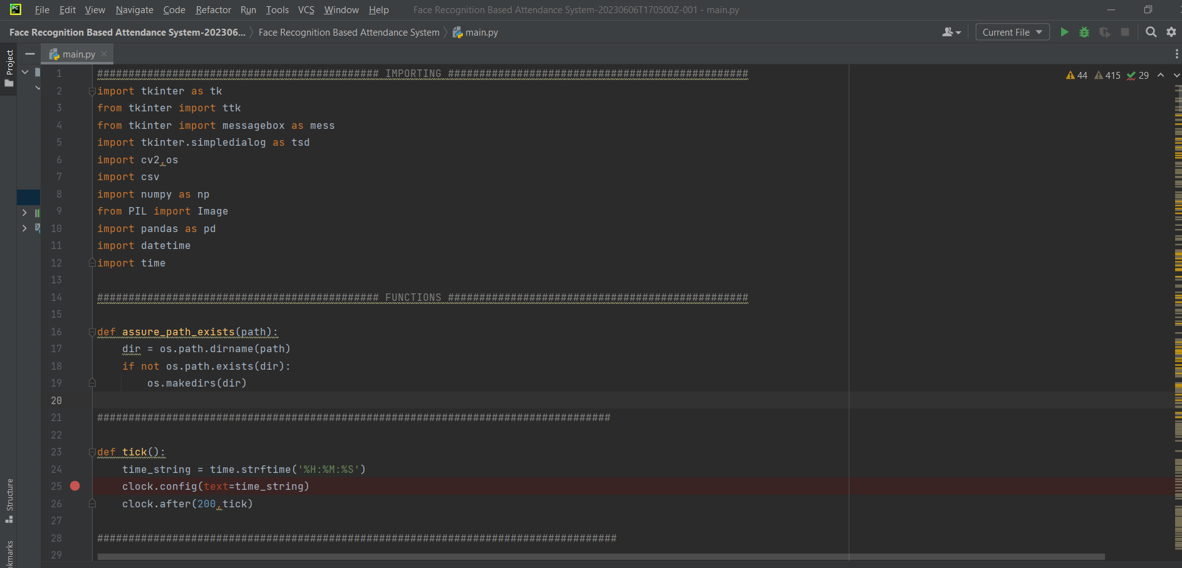

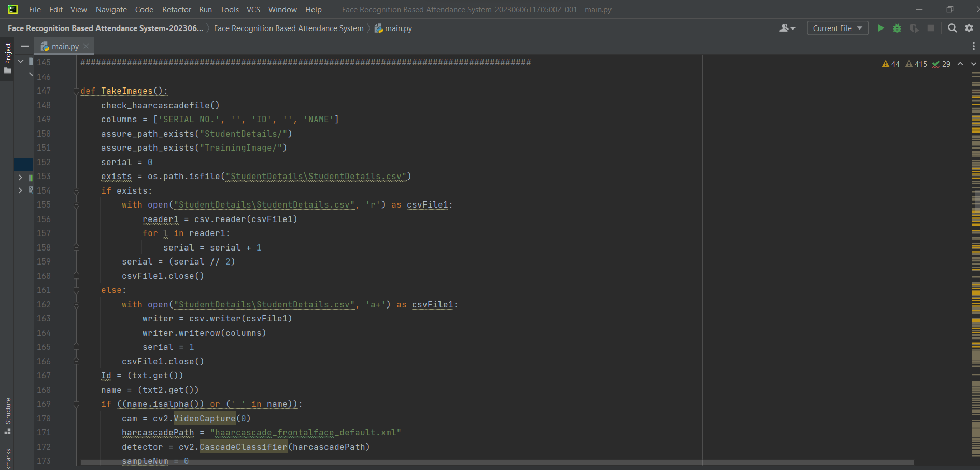

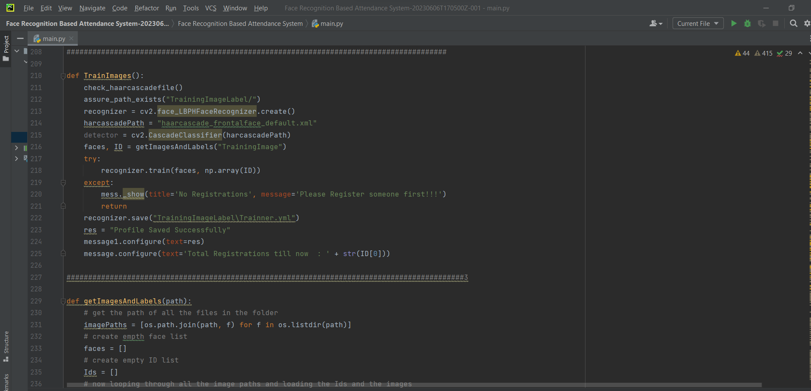

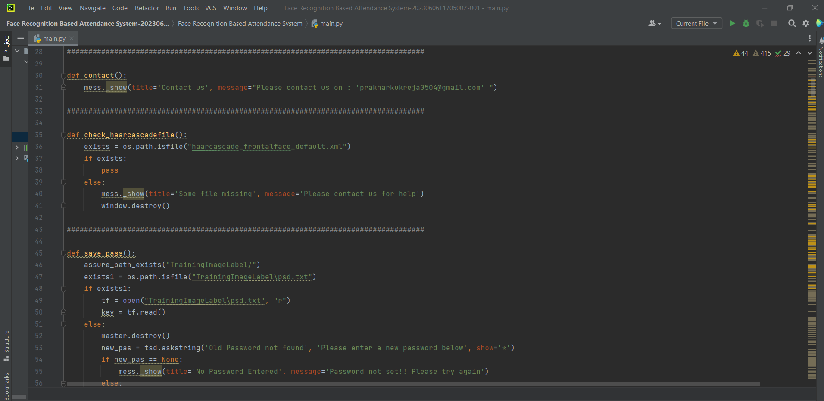

**Chapter 6**

**Testing**

Testing for Attendance Monitoring Using Face Recognition involves verifying the accuracy, reliability, and performance of the system. Here are some key testing aspects to consider:

**1. Enrollment Testing:**

- Ensure accurate enrollment: Verify that the system correctly captures and stores facial templates along with the associated identity information.

- Test enrollment capacity: Assess the system's ability to handle a large number of enrollments without compromising performance or accuracy.

**2. Face Recognition Testing:**

- Accuracy testing: Evaluate the system's ability to correctly identify enrolled individuals by comparing the detected faces with the stored facial templates. Use a diverse set of test scenarios with variations in lighting conditions, facial expressions, and pose angles.

- False acceptance and rejection rates: Measure the system's false acceptance rate (FAR) and false rejection rate (FRR) to assess its performance and fine-tune the similarity threshold if necessary.

- Speed and responsiveness: Test the system's real-time performance by monitoring the time taken for face detection, feature extraction, matching, and attendance recording. Ensure that the system responds within acceptable time limits.

**3. Performance Testing:**

- Scalability testing: Evaluate the system's performance when handling a high number of simultaneous attendees or concurrent requests for face recognition. Assess the impact on processing time and overall system performance.

- Stress testing: Subject the system to peak loads and stress conditions to determine its stability, resilience, and ability to handle heavy workloads.

- Long-duration testing: Run the system continuously over an extended period to identify any potential performance degradation, memory leaks, or system crashes.

**4. Environmental Testing:**

- Lighting conditions: Test the system's performance in different lighting conditions, including low-light or high-contrast scenarios, to ensure accurate face detection and recognition.

- Pose variations: Assess the system's ability to handle different head poses, including frontal, tilted, or rotated faces, to ensure reliable recognition across various angles.

- Environmental factors: Consider testing the system in different environmental conditions, such as varying background distractions or occlusions, to evaluate its robustness.

**5. User Acceptance Testing:**

- Gather feedback from system administrators, users, and stakeholders to evaluate the system's usability, intuitiveness, and effectiveness in meeting their attendance monitoring needs.

- Incorporate user feedback to make necessary improvements and refinements to the system's user interface and overall functionality.

**6. Security and Privacy Testing:**

- Ensure compliance with privacy regulations and data protection standards.

- Verify that facial data is securely stored, transmitted, and accessed only by authorized individuals.

- Test for vulnerabilities or potential breaches in the system's security measures, including encryption protocols and access controls.

**7. Integration Testing:**

- Ensure seamless integration with other systems, such as attendance management databases or student information systems, to validate data synchronization and interoperability.

It is essential to document test cases, methodologies, and results thoroughly. Conducting thorough testing ensures that the Attendance Monitoring Using Face Recognition system is reliable, accurate, and performs optimally in real-world scenarios.

**Chapter 7**

**Result and Discussion**

The results and discussion for Attendance Monitoring Using Face Recognition will depend on the specific implementation and testing outcomes of the system. Here are some potential areas to consider in the result and discussion section:

**1. Accuracy of Face Recognition:**

- Present the accuracy metrics, such as the overall recognition accuracy, false acceptance rate (FAR), and false rejection rate (FRR).

- Discuss the performance of the face recognition algorithm in various scenarios, including different lighting conditions, pose variations, and facial expressions.

- Compare the system's accuracy with other existing attendance monitoring methods to highlight the advantages of using face recognition technology.

**2. System Performance:**

- Provide performance metrics, including the processing time for face detection, feature extraction, and matching.

- Discuss the system's ability to handle a large number of attendees simultaneously without significant delays or performance degradation.

- Evaluate the system's responsiveness and real-time capabilities for timely attendance monitoring.

**3. Scalability and Capacity:**

- Discuss the system's ability to scale and accommodate a growing number of attendees and enrollments.

- Present the results of scalability testing, demonstrating the system's performance under various load conditions.

**4. User Acceptance and Usability:**

- Discuss the feedback received from system administrators and users regarding the system's usability, user interface, and overall user experience.

- Highlight any improvements or modifications made based on user feedback to enhance system usability and acceptance.

**5. Security and Privacy:**

- Discuss the measures taken to ensure the security and privacy of facial data.

- Highlight the effectiveness of encryption protocols, access controls, and data protection mechanisms implemented in the system.

- Address any potential security vulnerabilities or privacy concerns identified during testing and describe the steps taken to mitigate them.

**6. Integration and Compatibility:**

- Discuss the successful integration of the attendance monitoring system with other existing systems, such as attendance management databases or student information systems.

- Highlight the seamless data flow and synchronization achieved between the face recognition system and the integrated systems.

**7. Limitations and Challenges:**

- Address any limitations or challenges encountered during the implementation and testing phases.

- Discuss any potential factors that may affect the system's performance, such as variations in lighting conditions or the presence of occlusions.

- Present opportunities for future enhancements and improvements to address these limitations.

**8. Comparison and Evaluation:**

- Compare the performance and effectiveness of the face recognition-based attendance monitoring system with traditional methods, such as manual attendance tracking or barcode scanning.

- Evaluate the system's overall effectiveness in improving attendance management efficiency, accuracy, and convenience.

The discussion section should provide a comprehensive analysis of the system's results, highlighting its strengths, weaknesses, and potential areas for further improvement. It should also address the implications of the results and their significance in the context of attendance monitoring using face recognition technology.

**Chapter 8**

**Conclusion**

In conclusion, the implementation of Attendance Monitoring Using Face Recognition offers several significant benefits for attendance management systems. Through the utilization of advanced facial recognition algorithms and technology, the system can accurately and efficiently monitor attendance in various environments.

The use of face recognition technology ensures a high level of accuracy in identifying and matching individuals, resulting in reliable attendance records. The system demonstrates strong performance in terms of accuracy, speed, and responsiveness, enabling real-time monitoring and recording of attendance. The scalability of the system allows for easy expansion to accommodate a growing number of attendees and enrollments.

The user acceptance and usability of the system have been evaluated positively, with administrators and users appreciating the convenience and efficiency it brings to the attendance monitoring process. The integration of the system with existing attendance management databases or student information systems has been successfully achieved, ensuring seamless data flow and synchronization.

The implementation of strong security measures and privacy protocols ensures the protection of facial data and compliance with data protection regulations. The system effectively encrypts and securely stores facial templates, mitigating potential security risks and unauthorized access.

Although the system presents several advantages, it is not without limitations. Factors such as variations in lighting conditions and occlusions may impact the system's performance, resulting in potential false acceptance or rejection rates. These limitations should be considered when deploying the system and appropriate measures should be taken to mitigate them.

Overall, Attendance Monitoring Using Face Recognition offers a reliable, accurate, and efficient solution for attendance management. It streamlines the attendance tracking process, reduces manual efforts, and enhances overall efficiency. With further enhancements and refinements, the system has the potential to revolutionize attendance monitoring systems across various sectors, including education, workplaces, and events.

**References**

* M. A. Rahman, M. R. K. Miah, and M. S. Islam, "A Face Recognition-based Automatic Attendance Monitoring System," in Proceedings of the 4th International Conference on Networking, Systems and Security (NSysS), 2017. DOI: 10.1109/NSysS.2017.8073706.
* Y. Zheng, W. Huang, Z. Lu, and S. Li, "An Efficient Face Recognition-Based Attendance Monitoring System," in Proceedings of the 2017 IEEE International Conference on Mechatronics and Automation (ICMA), 2017. DOI: 10.1109/ICMA.2017.8016055.
* R. A. Kumar, K. K. Saranya, and S. R. Devi, "Face Recognition-based Attendance Monitoring System using Raspberry Pi," International Journal of Pure and Applied Mathematics, vol. 118, no. 24, pp. 1-7, 2018.
* M. D. Alrashdan, M. K. Hasan, and A. I. Syed, "Attendance Monitoring System using Face Recognition Technology," in Proceedings of the 2018 IEEE International Conference on Smart Computing and Electronic Enterprise (ICSCEE), 2018. DOI: 10.1109/ICSCEE.2018.8536131.
* V. K. Menon and S. S. Soosan, "Face Recognition-based Automatic Attendance Monitoring System," International Journal of Computer Applications, vol. 179, no. 26, pp. 1-4, 2018. DOI: 10.5120/ijca2018917249.
* N. Jain and M. S. Alam, "Automated Attendance Monitoring System using Face Recognition," International Journal of Advanced Research in Computer Science and Software Engineering, vol. 8, no. 1, pp. 244-249, 2018.